PRE-REQUISITES:

GIT

JAVA JDK 1.7

NODE JS Any latest version

Navigate to <https://dcstash.service.dev:8443/projects/TPD/repos/tpd-node-modules/browse>

Clone the repo path

0s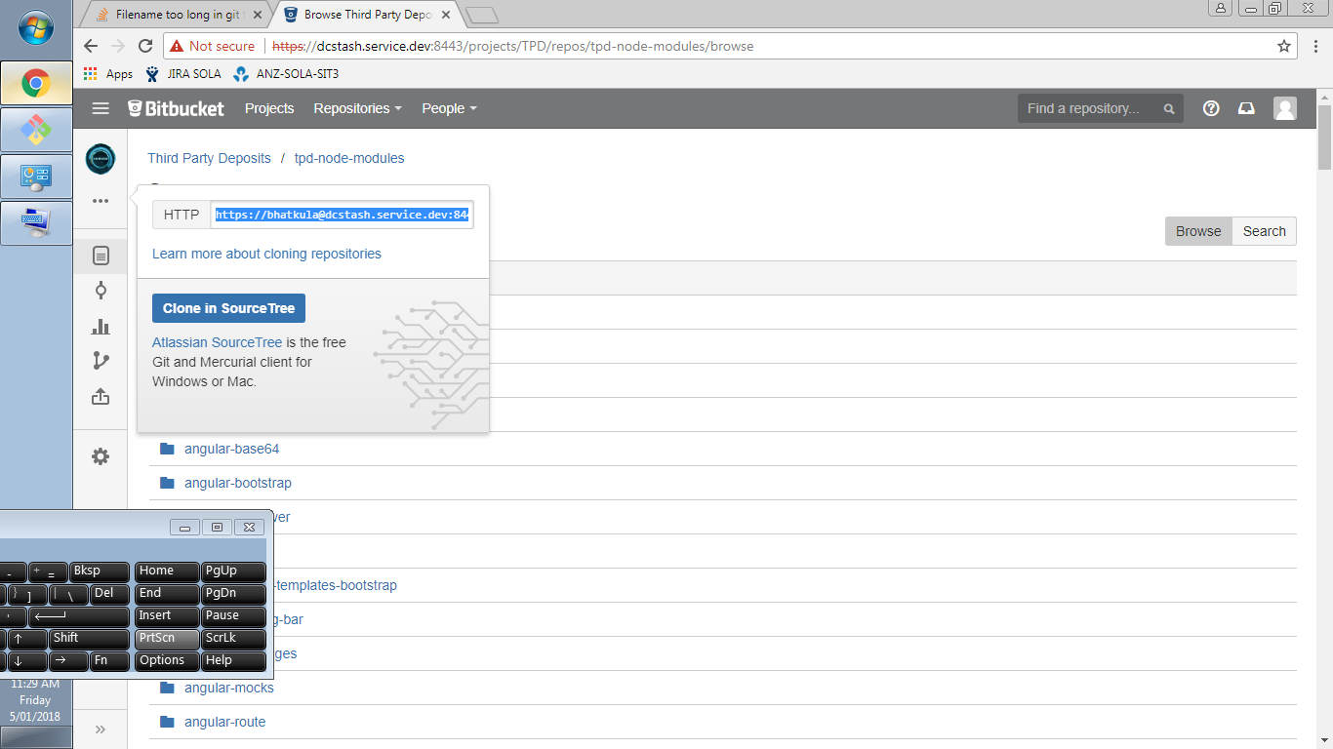

Open bash and navigate to the directory you want to clone this repository and then type the below command

GIT_SSL_NO_VERIFY=true git clone <https://bhatkula@dcstash.service.dev:8443/scm/tpd/tpd-node-modules.git>

GIT_SSL_NO_VERIFY=true git clone https://bhatkula@dcstash.service.dev:8443/scm/tpd/tpd-node-modules.git

